**Part1:Setting up my Forensic Workstation**

1. Install Windows 10 using VMware Workstation.

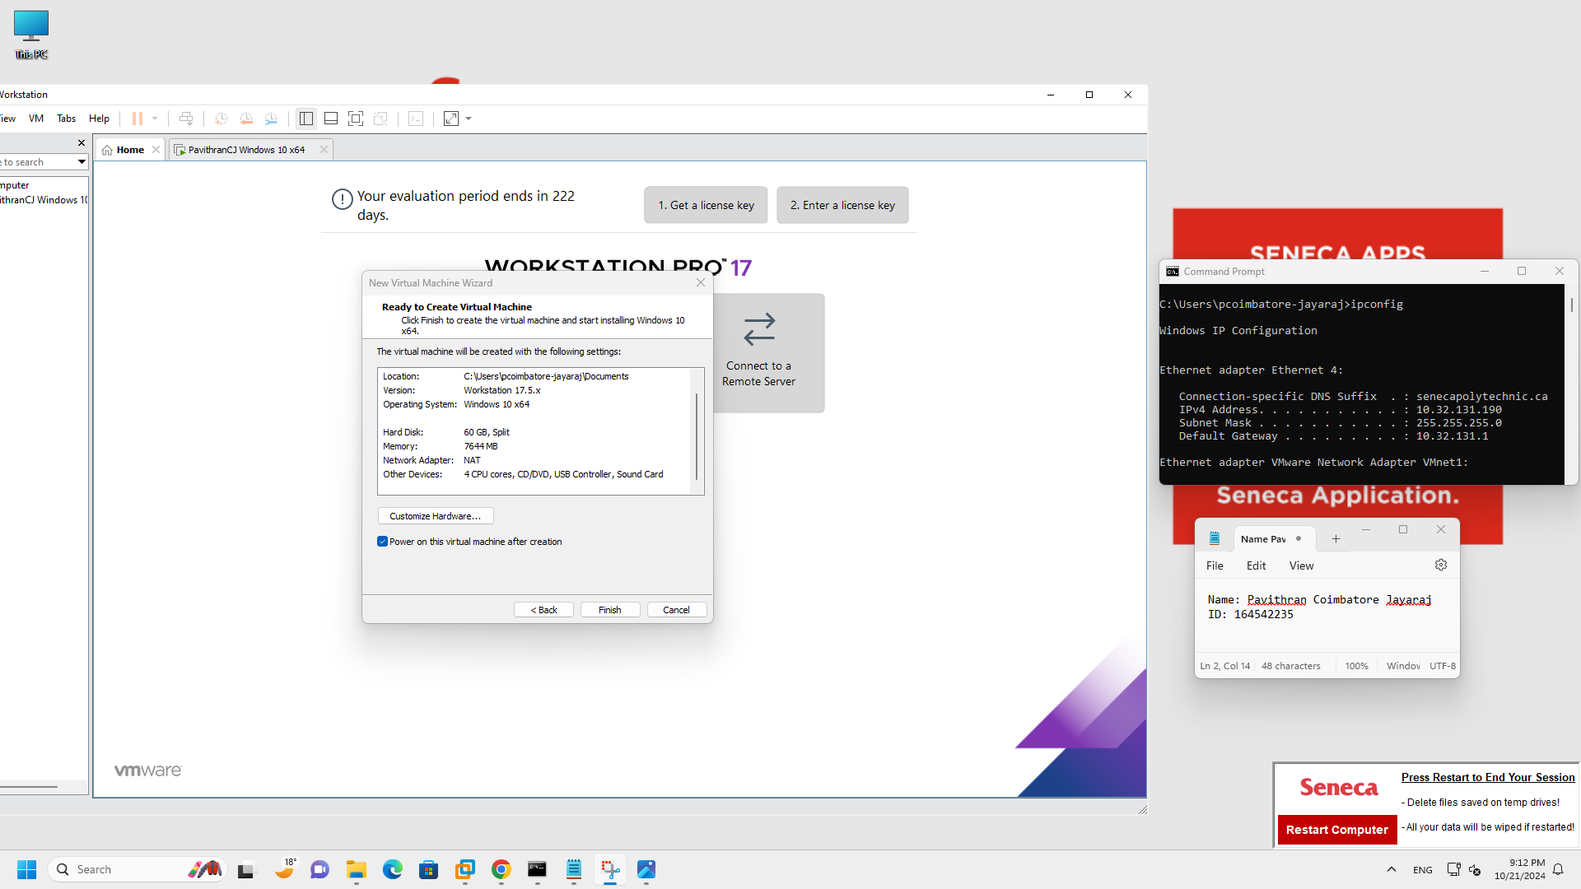

1. Enabling Windows Subsystem for Linux.

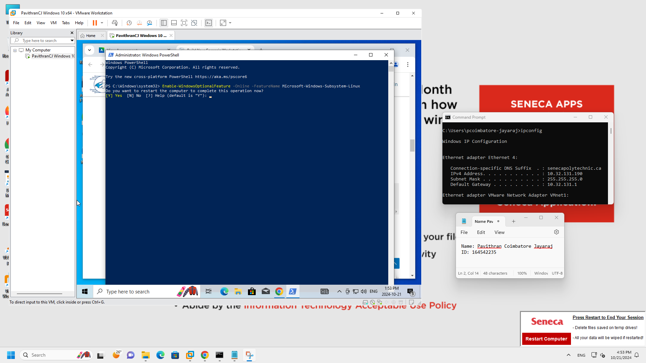

1. Setup username and Password after Installing Ubuntu 20.04.

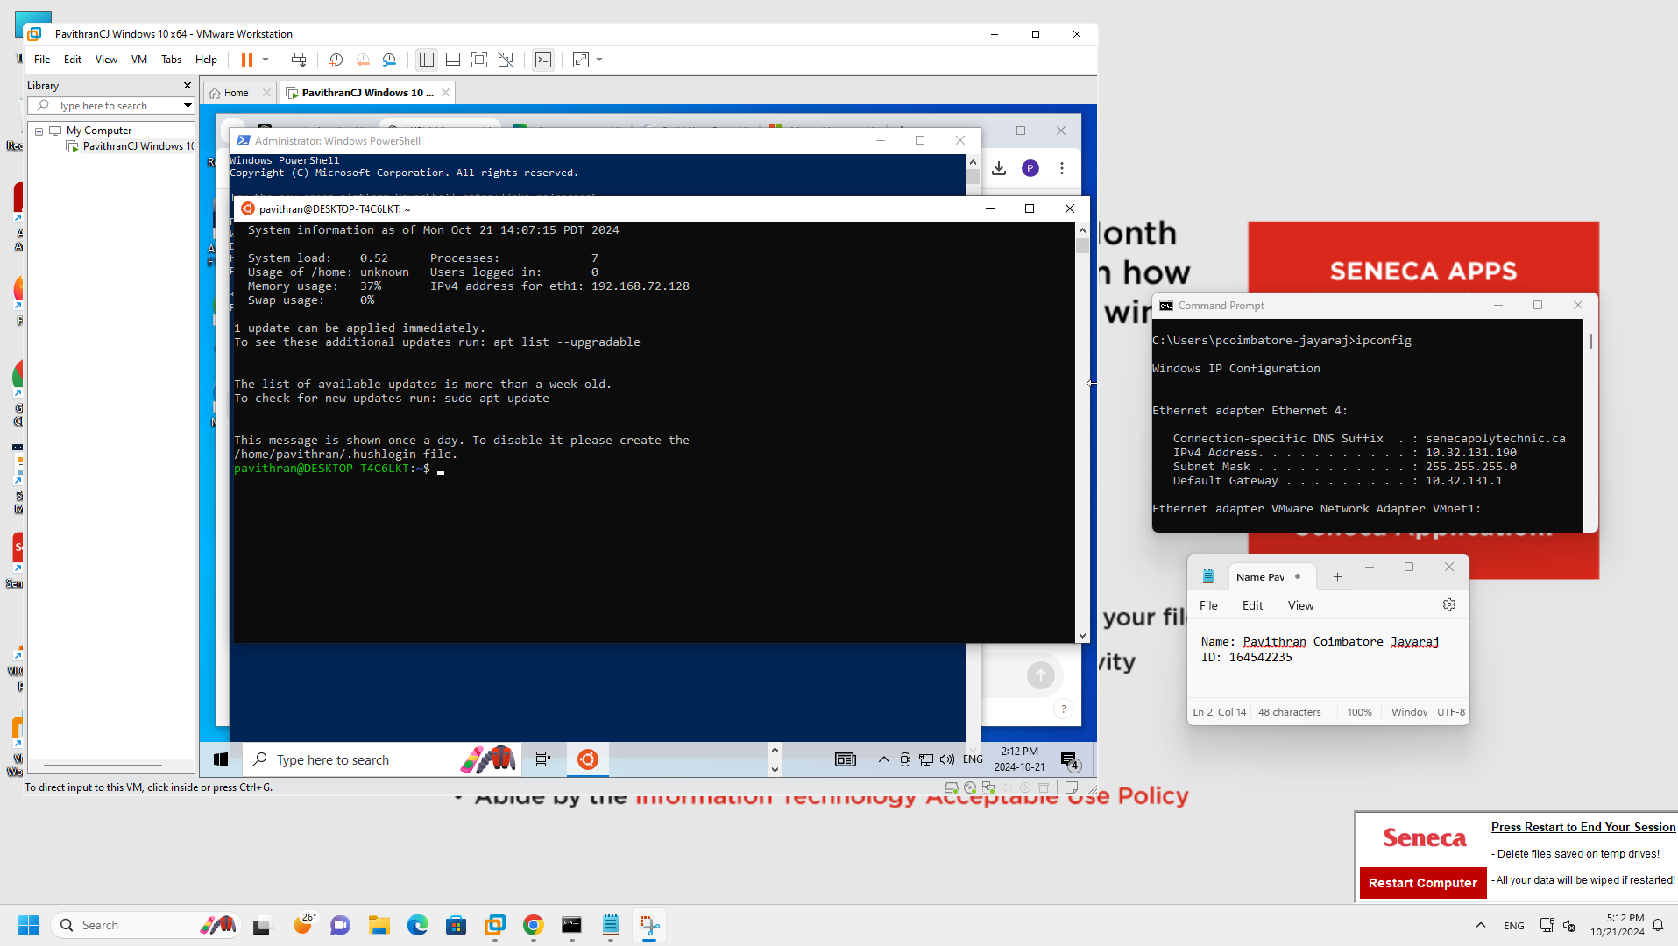

1. Proof that WSL1 is the version we are using, and Ubuntu is running.

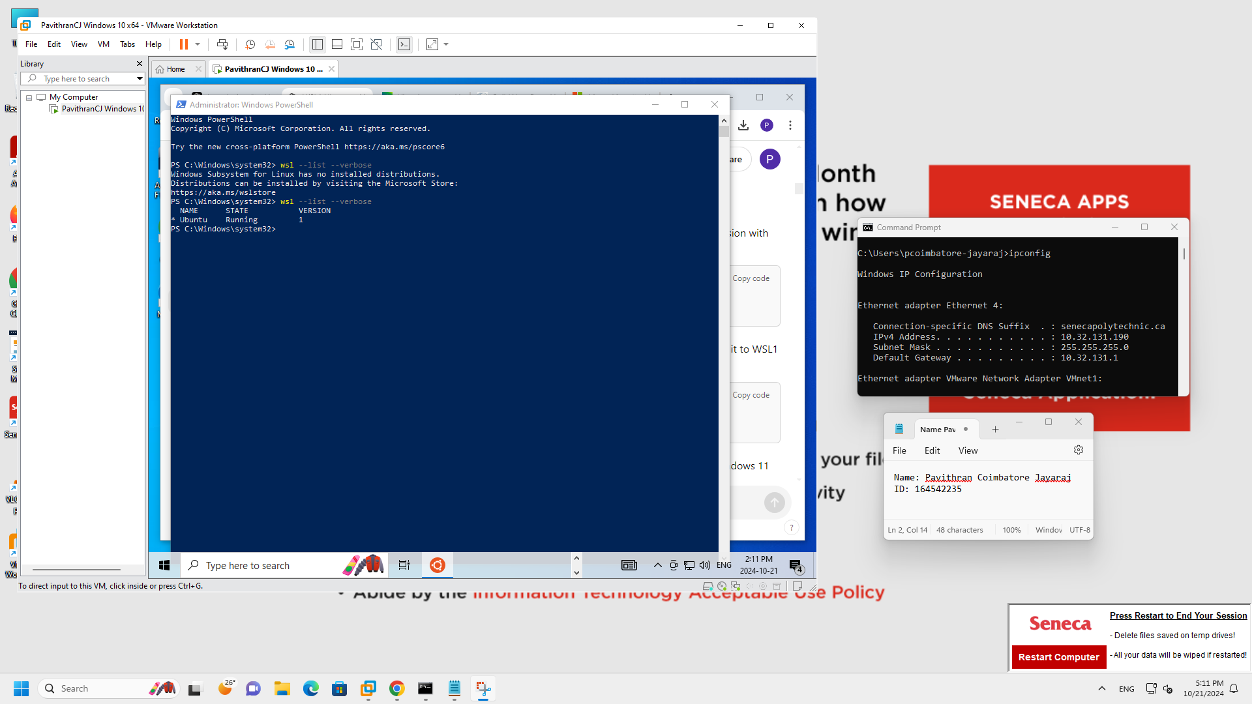

1. Configuring the windows environment by setting time zone to UTC.

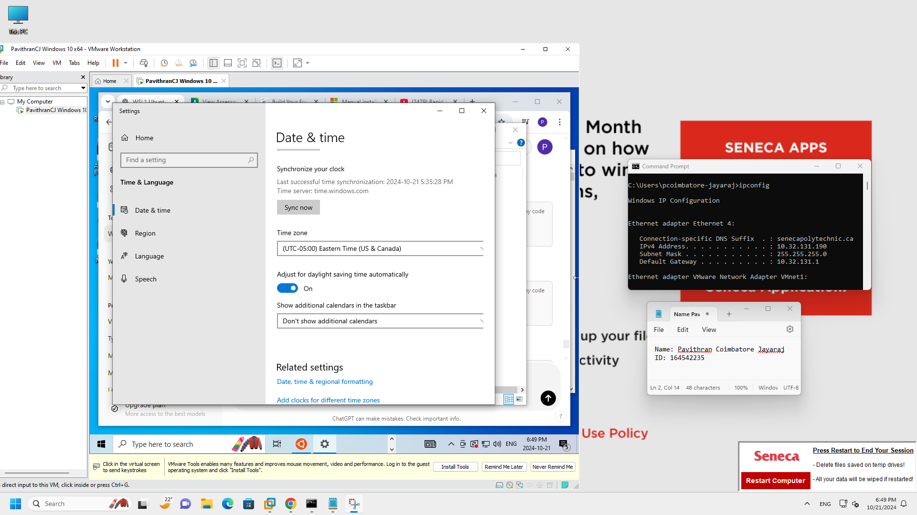

1. Check file name extension and hidden files for better visibility for crucial files.

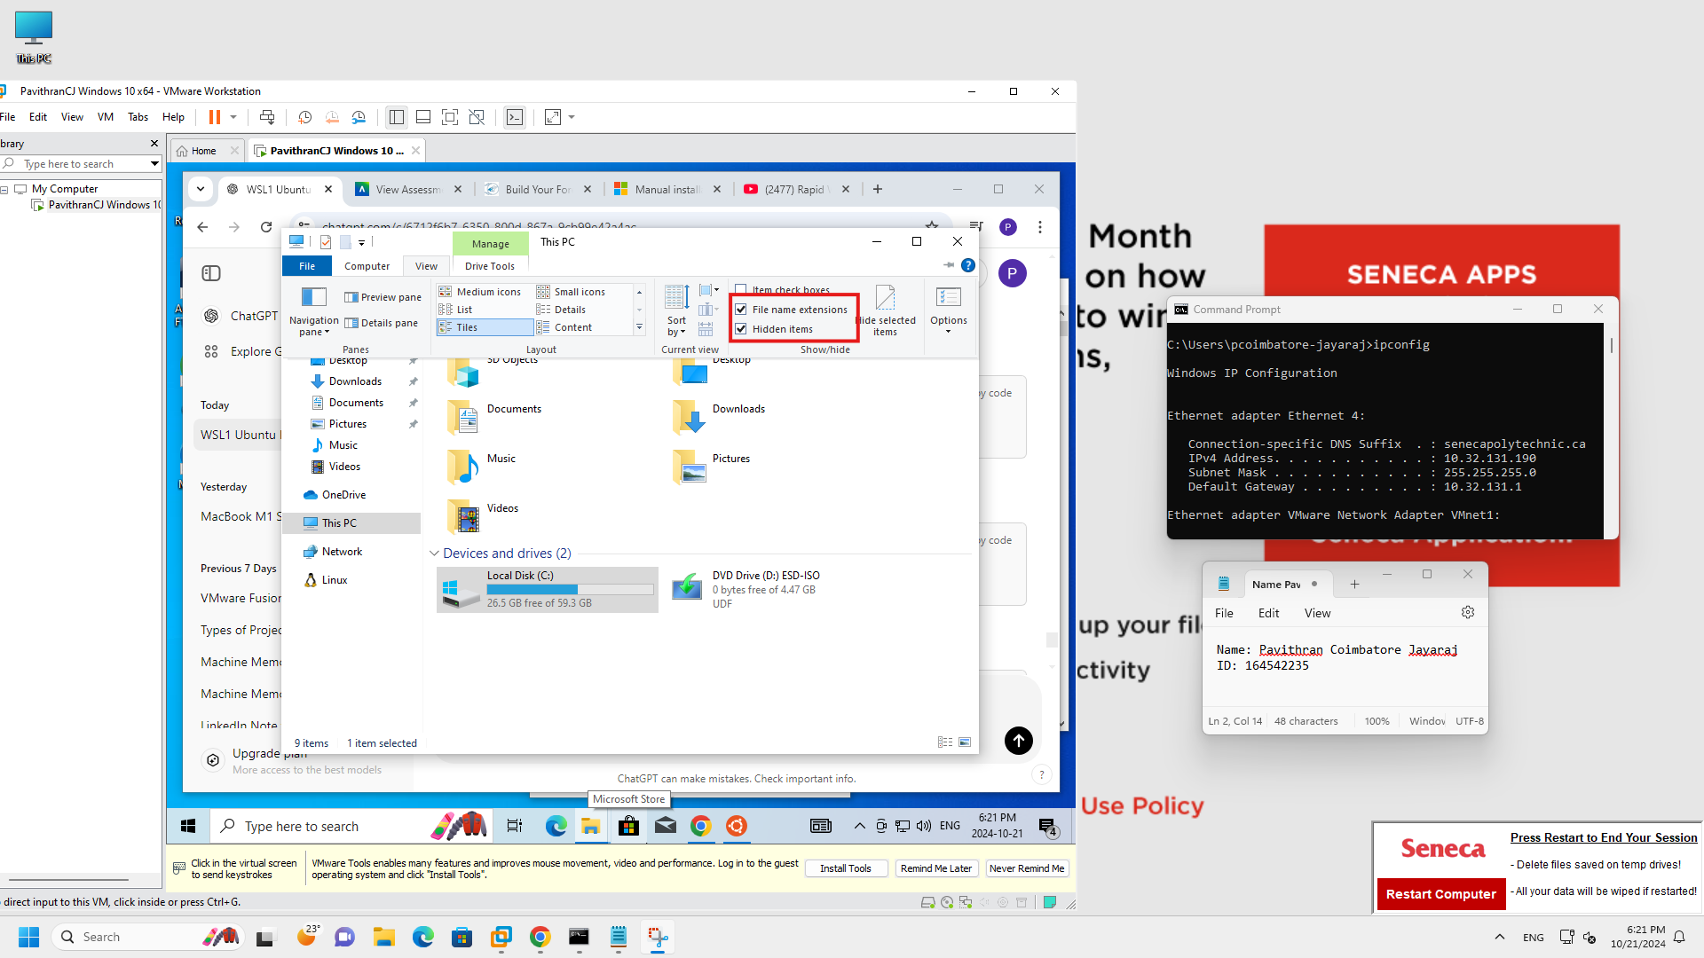

1. Create separate folders for case and tools for forensic evidence and tool storage.

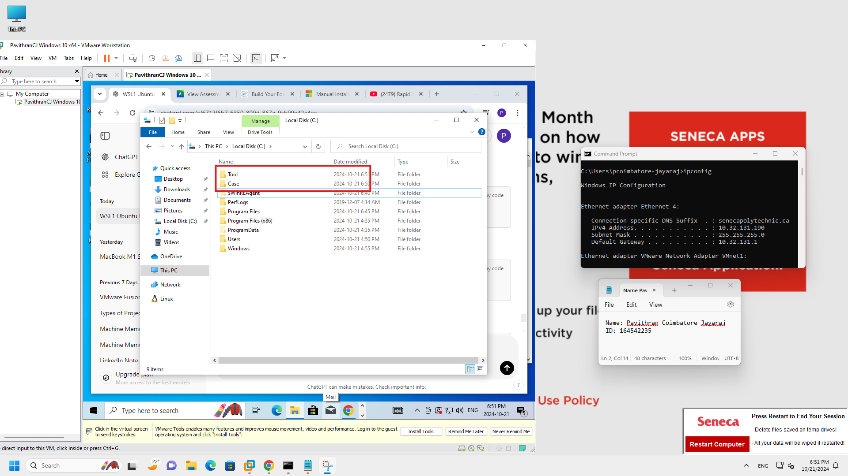

1. Configure Microsoft Defender to avoid interference with evidence or tools by Disableling Defender’s “Real-time protection” and “Cloud-delivered protection” and “Automatic sample submission”.

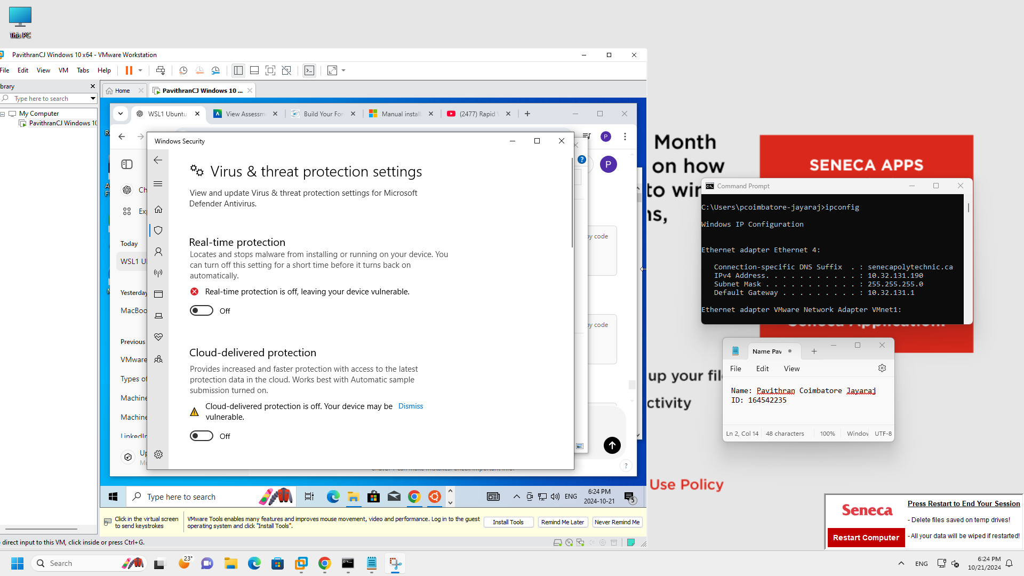

1. Exclude your working directories e.g. “C:\Cases” and “C:\Tools” from Defender’s virus and threat protection scanning. That way Defender won’t detect and remove important files during an investigation.

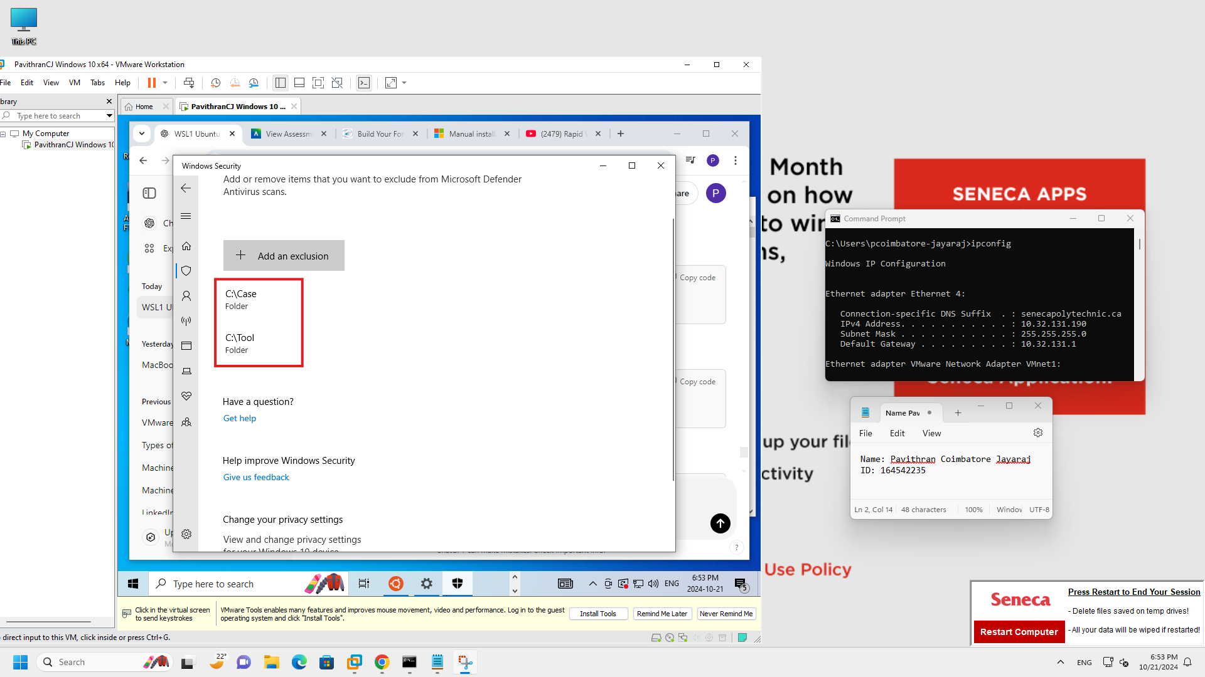

1. Install Forensic tools (Linux based)

* pip3 – Python packet manager

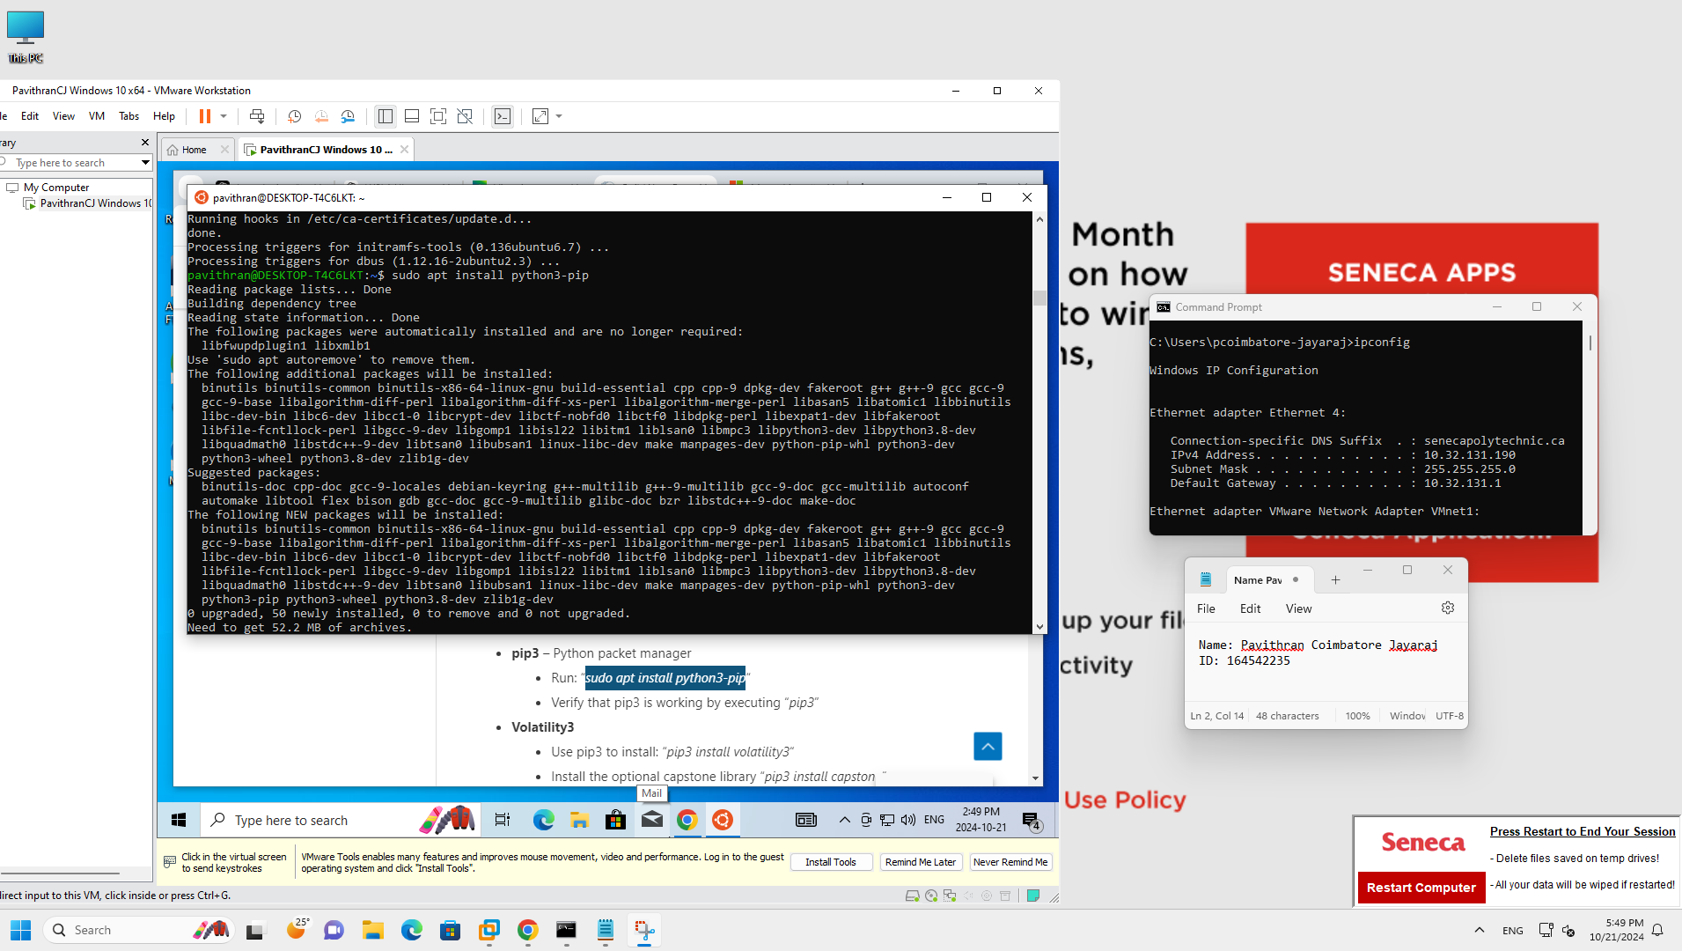

* Volatility3- install and check if its working

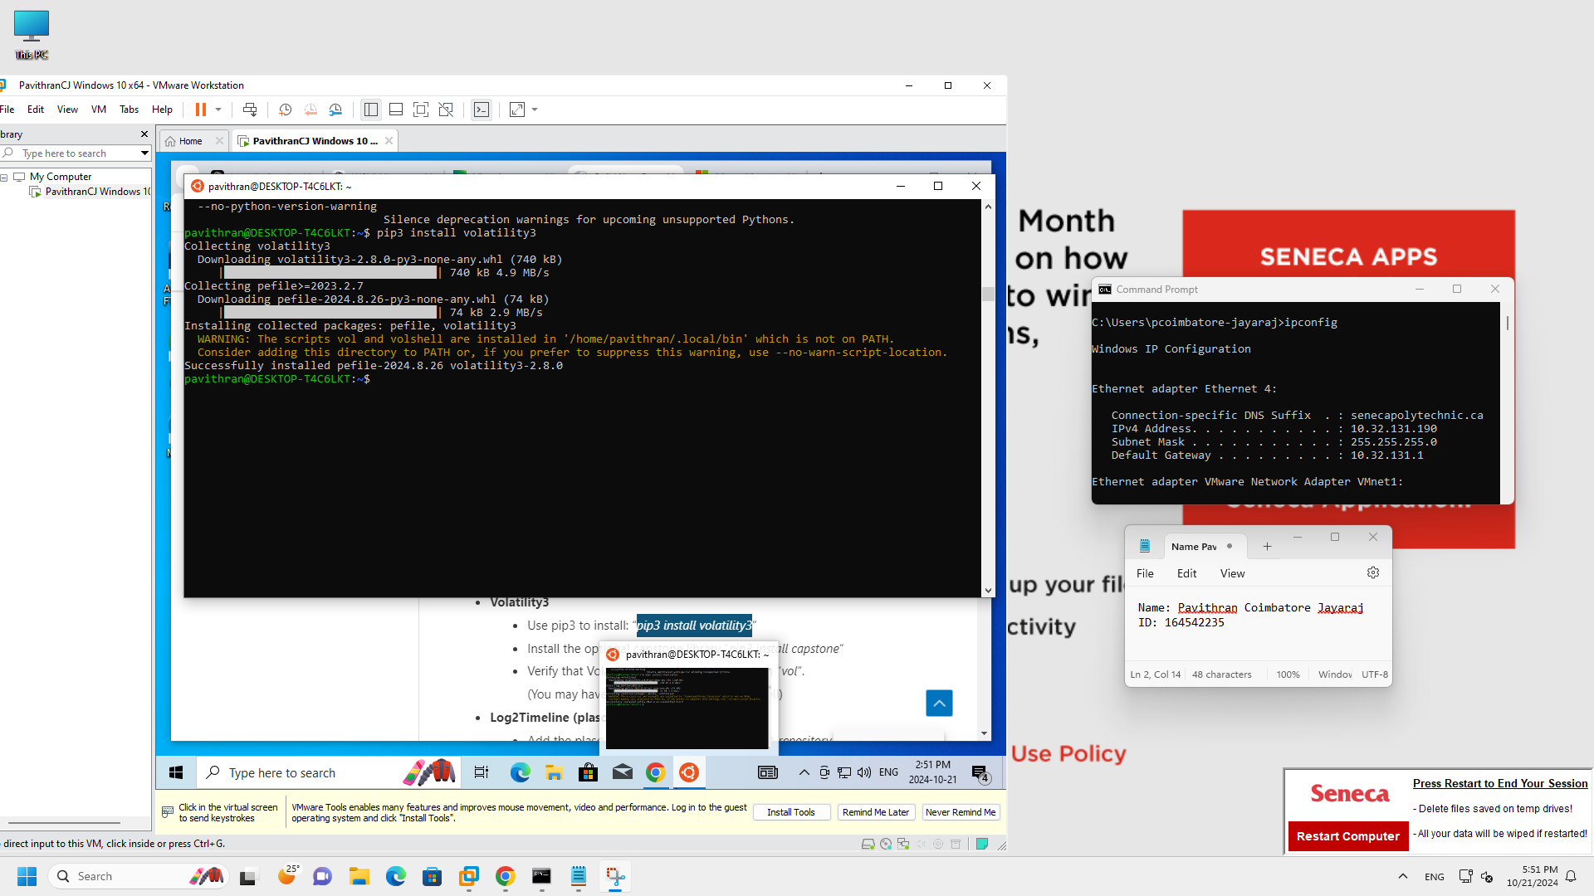

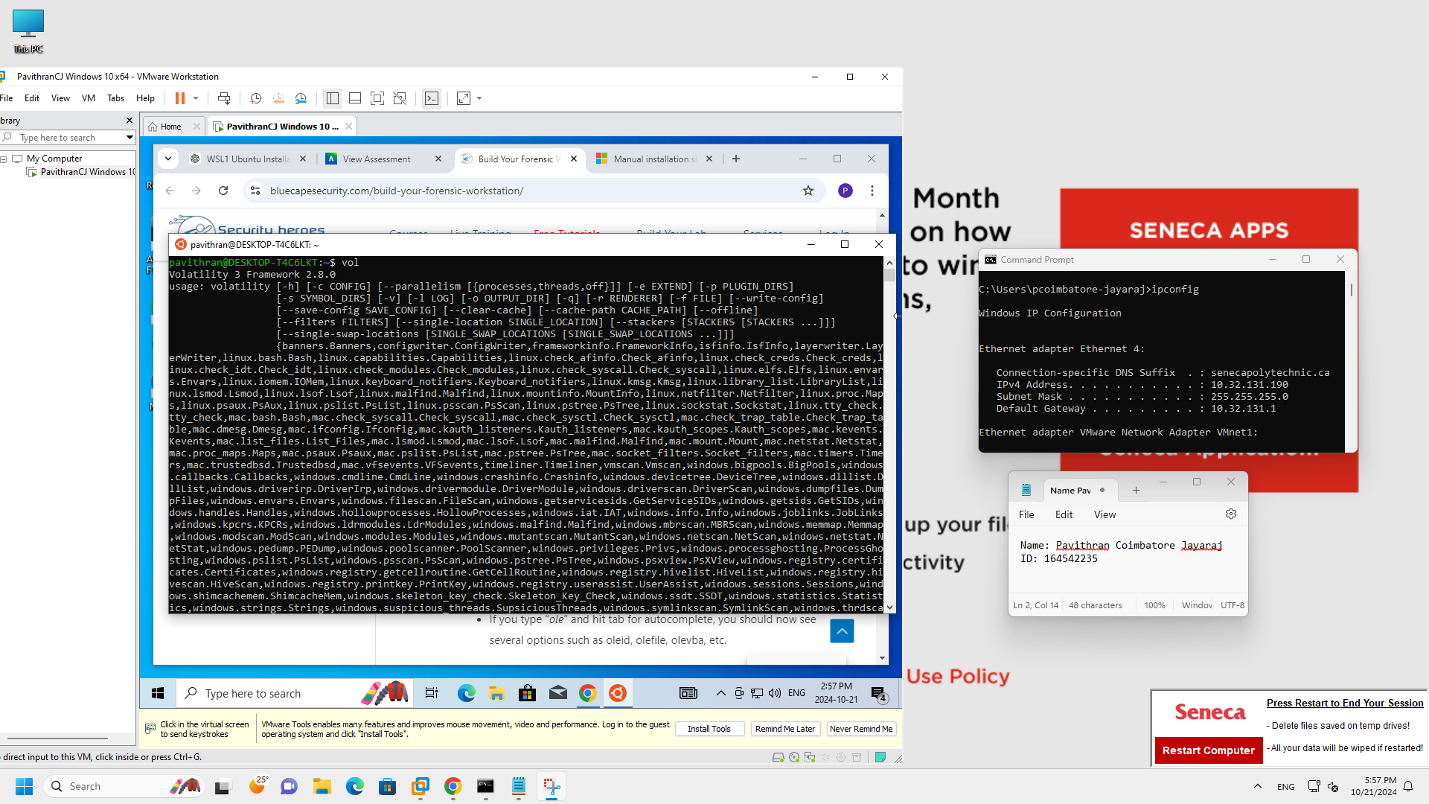

* Log2Timeline (plaso tools)-add plaso reposotary and install and check if it works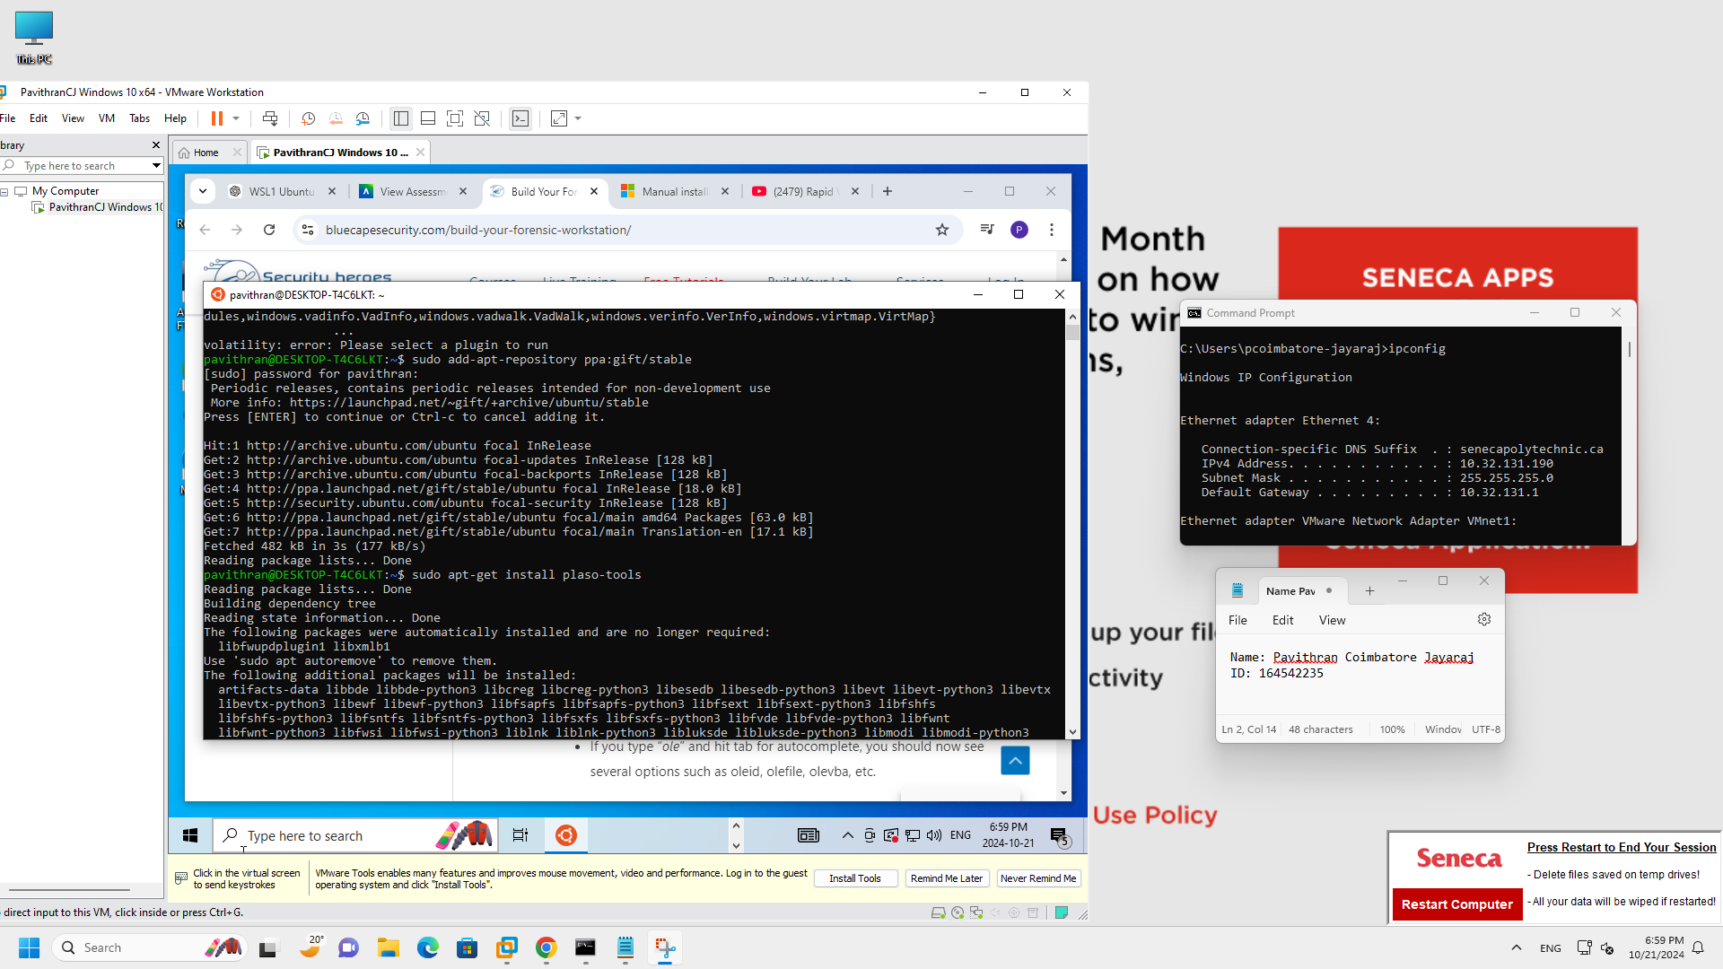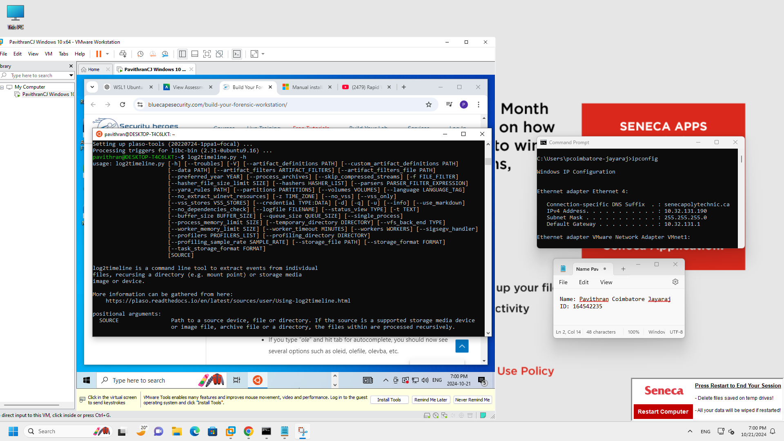
* Oletools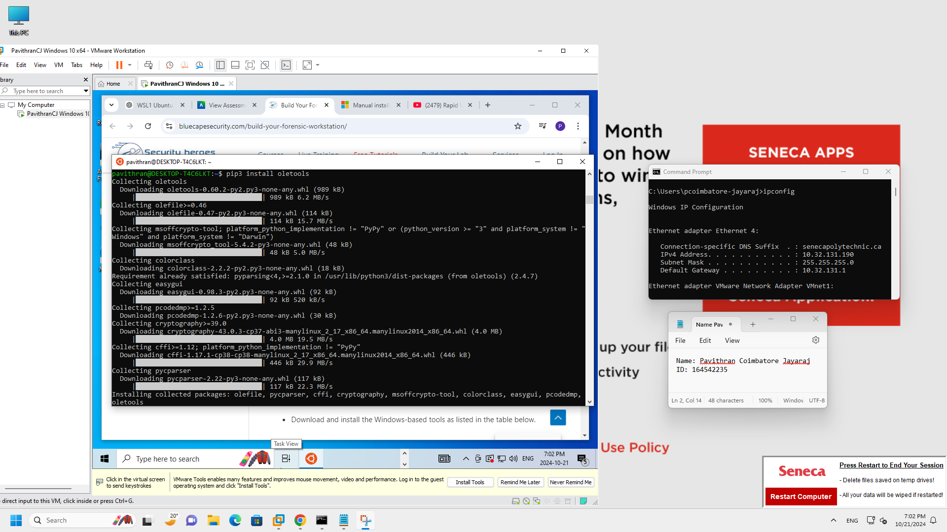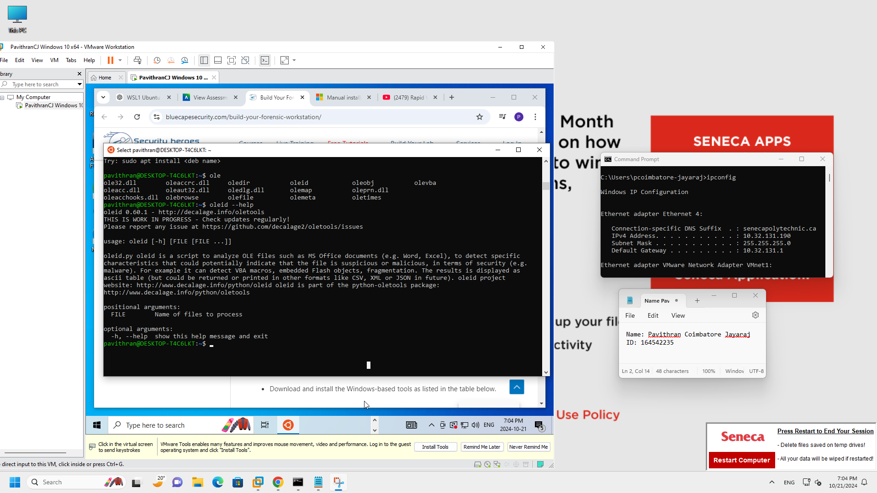

1. Install Forensic tools (windows based)

* 7-Zip
* Microsoft VS Code
* FTK Imager
* Wireshark
* Dumpit

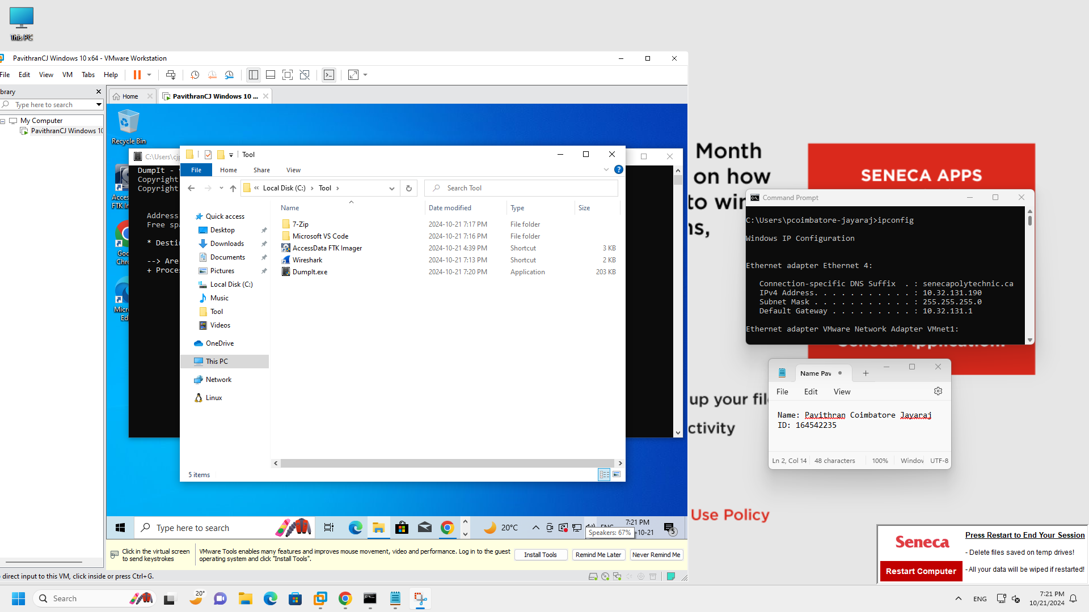

**Part 2: Memory Analysis**

1. **Voaltility**

* Use FTK Imager to capture memory Image.

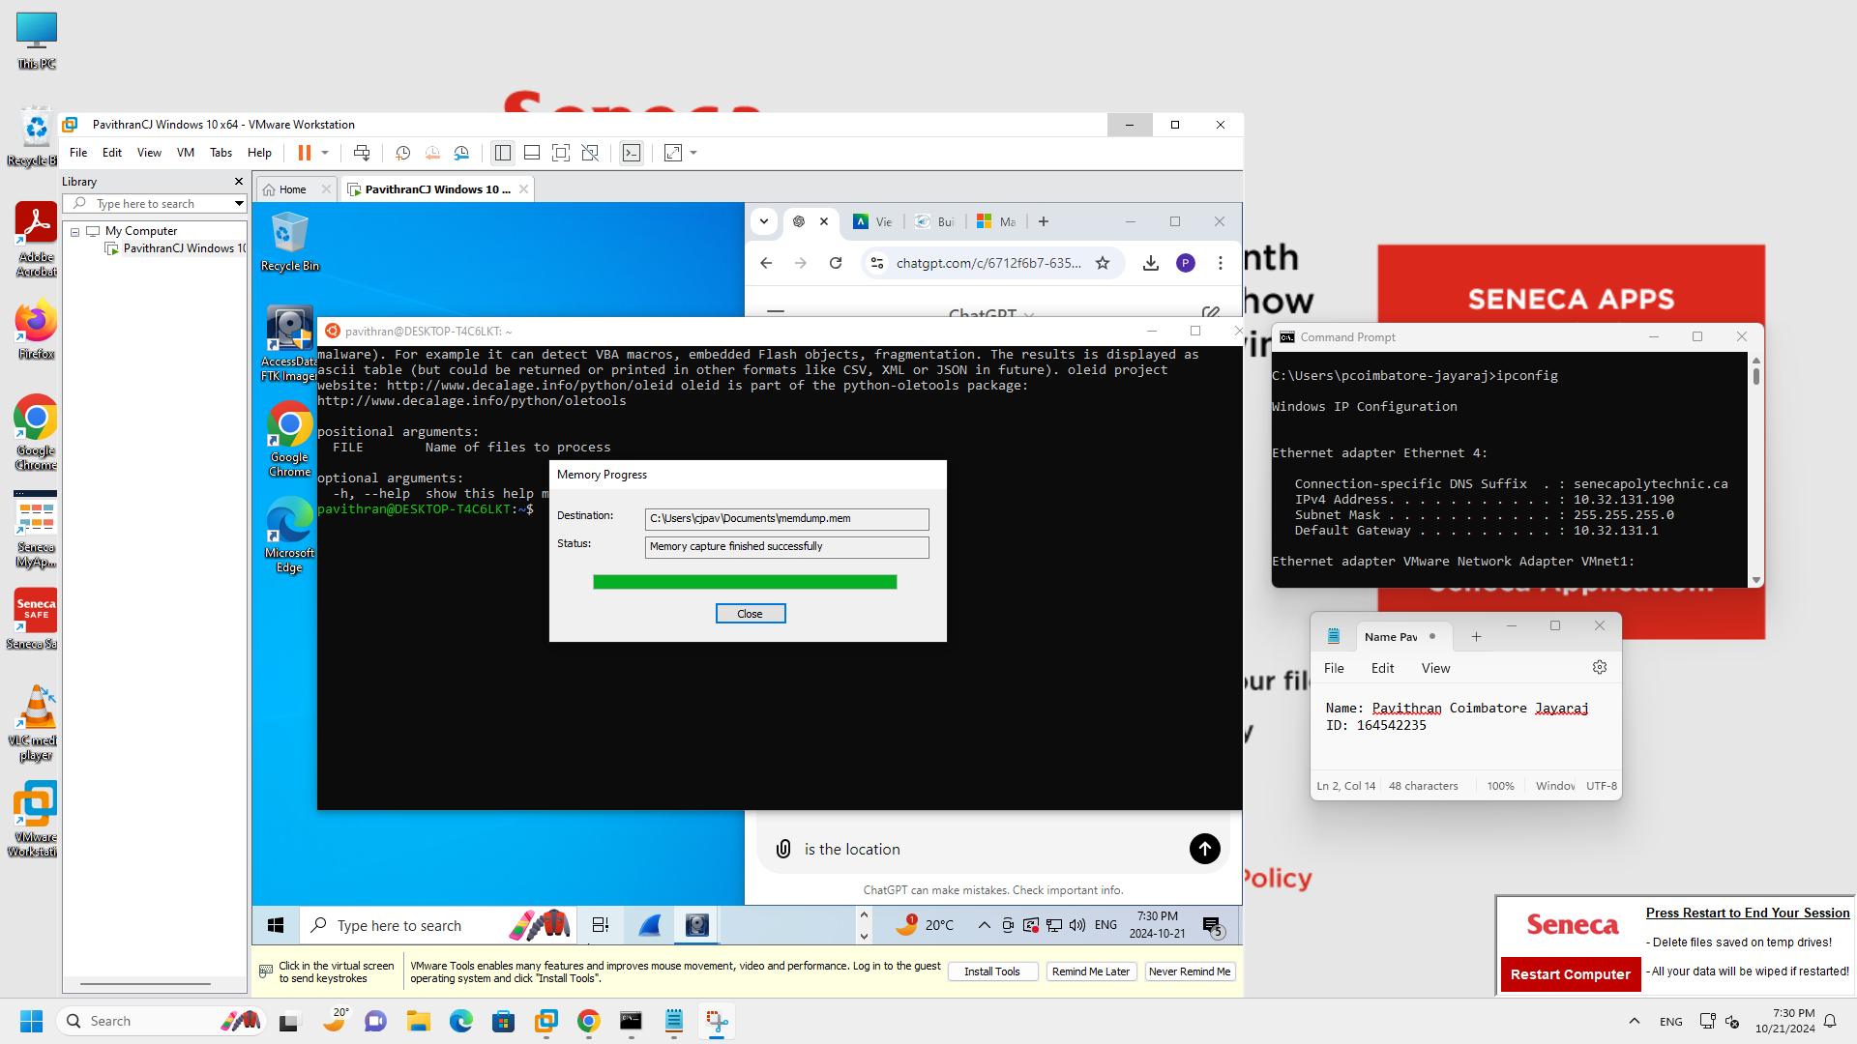

* Pslist command will show you a list of active processes in the system at the time the memory dump was captured, including the process name, process ID (PID), and parent process ID (PPID).

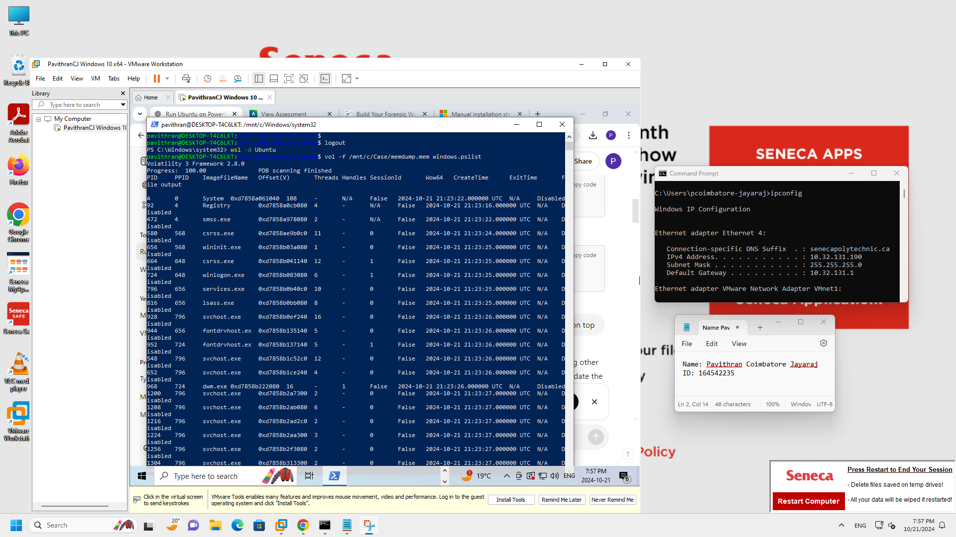

* dlllist command will provide a list of all DLLs loaded into each process's memory, including the base address, size, and path of the DLLs. It is useful for identifying suspicious or malicious DLLs loaded into processes.

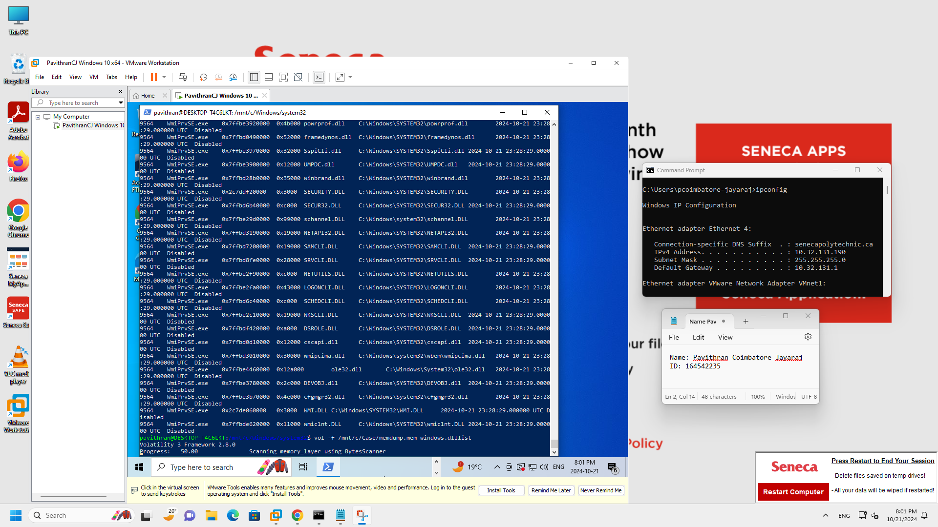

* The netscan plugin scans for TCP and UDP endpoints, along with listening sockets, and provides details

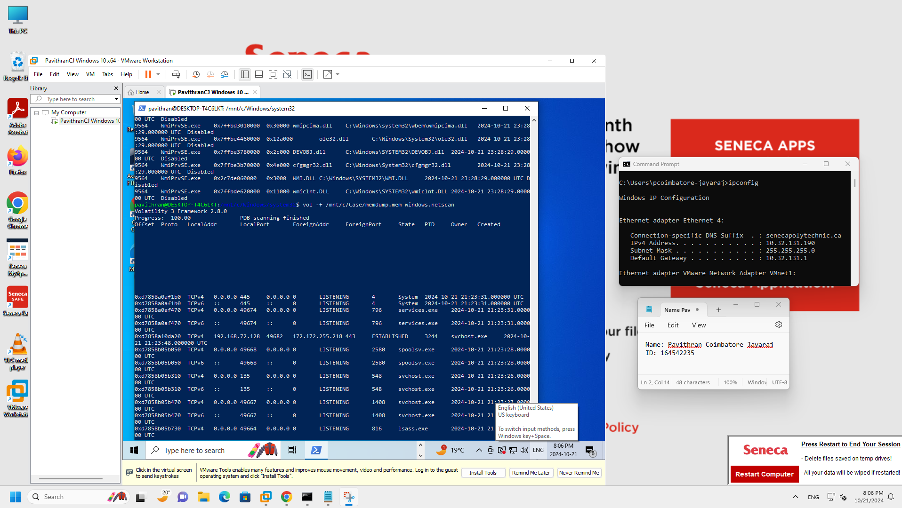

1. **Redline**

* Download and install redline from the website.

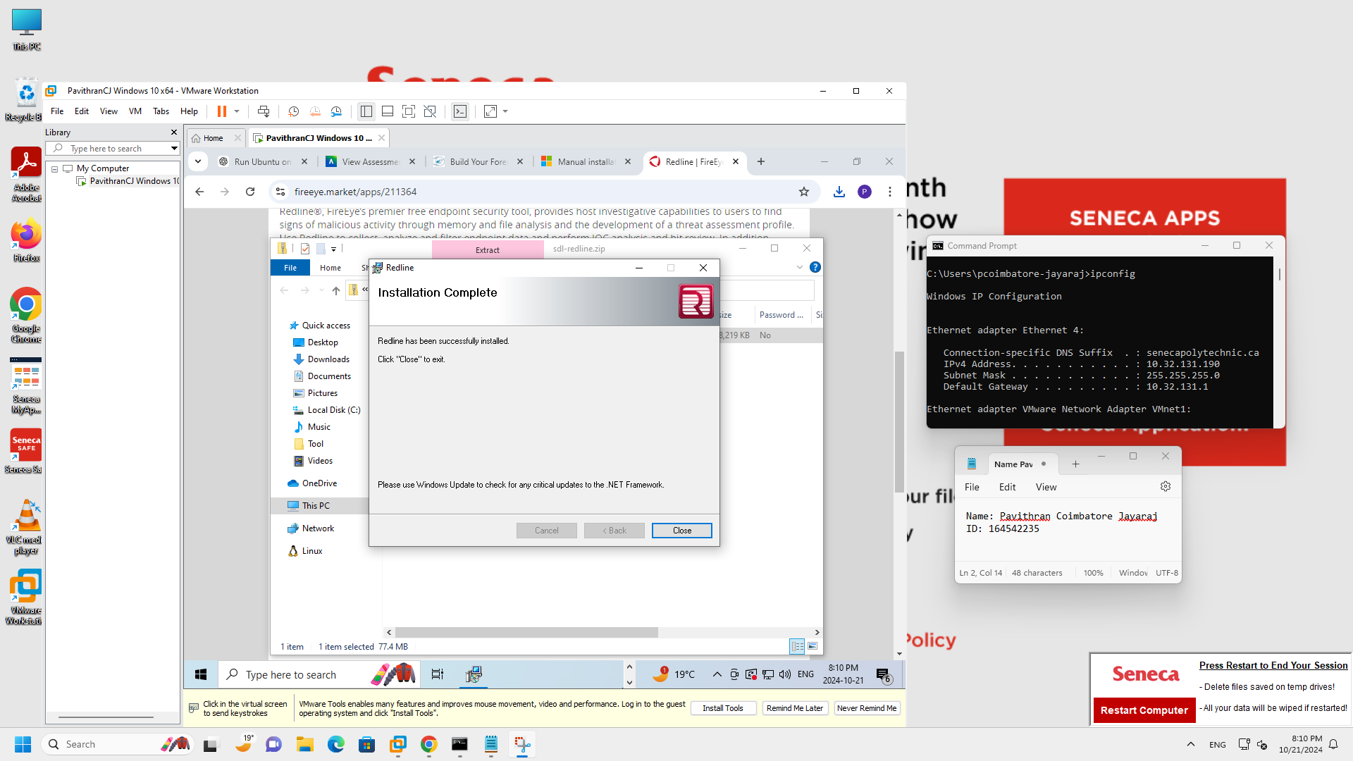

* Capture Image first by giving target platform as windows and check the acquire memory image checkbox and give a location for it to be stored.

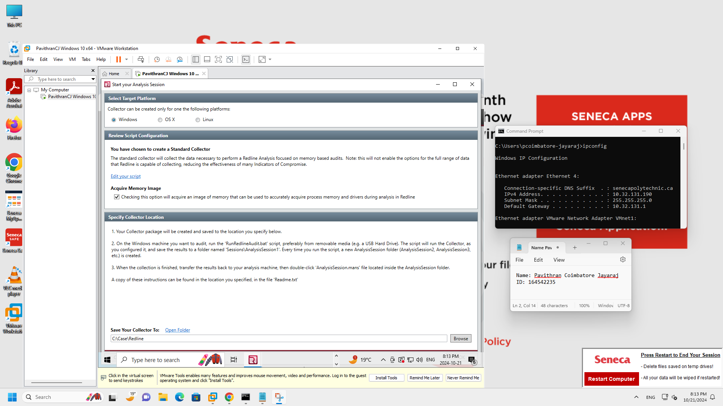

* Run the redline analysis session and click on host base based on an external investigative lead to see if external subspinous or malicious activities exists.

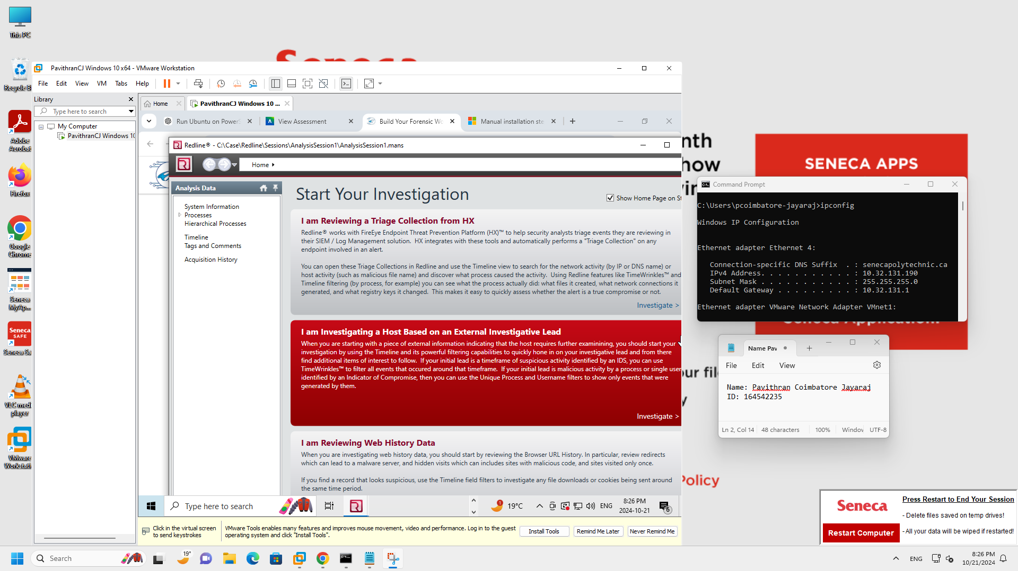

* Used timeline configuration to filter files, process, registry etc based on timestamps.

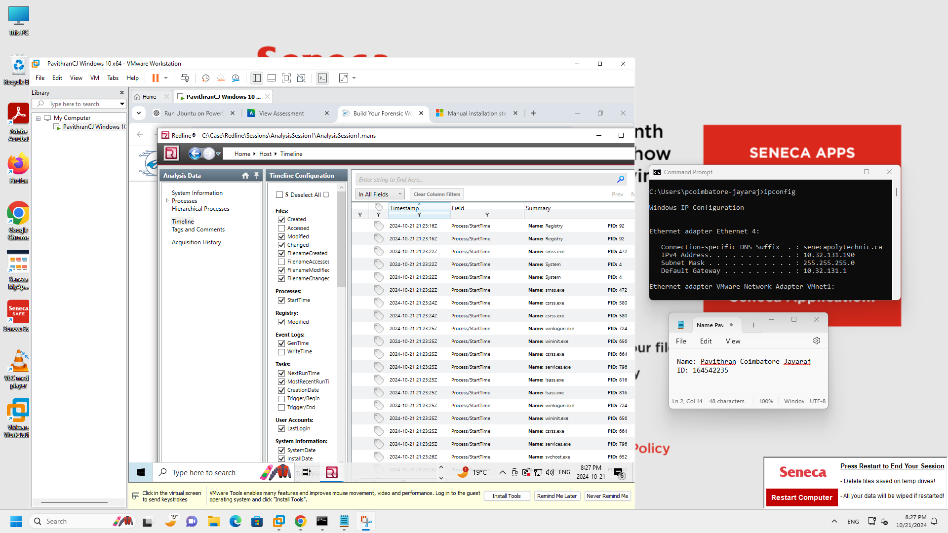

* The system Information gives the details of the system as shown below.

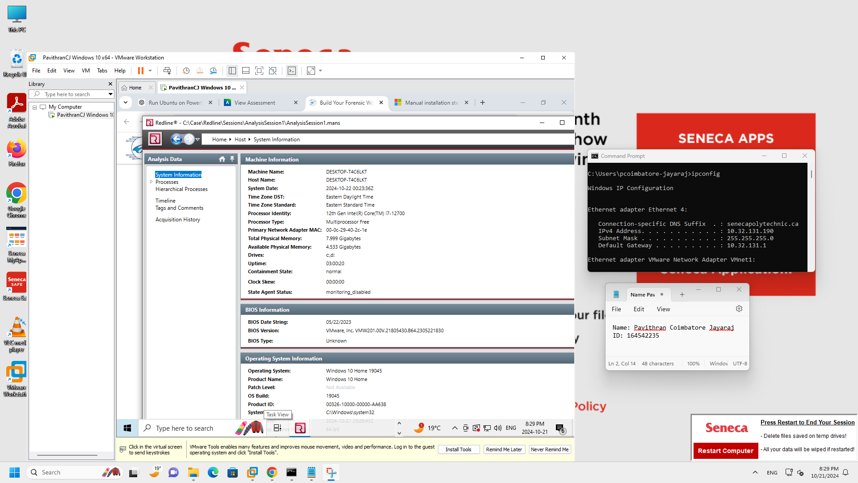

1. **Cyber Triage**

* Download and install the tool

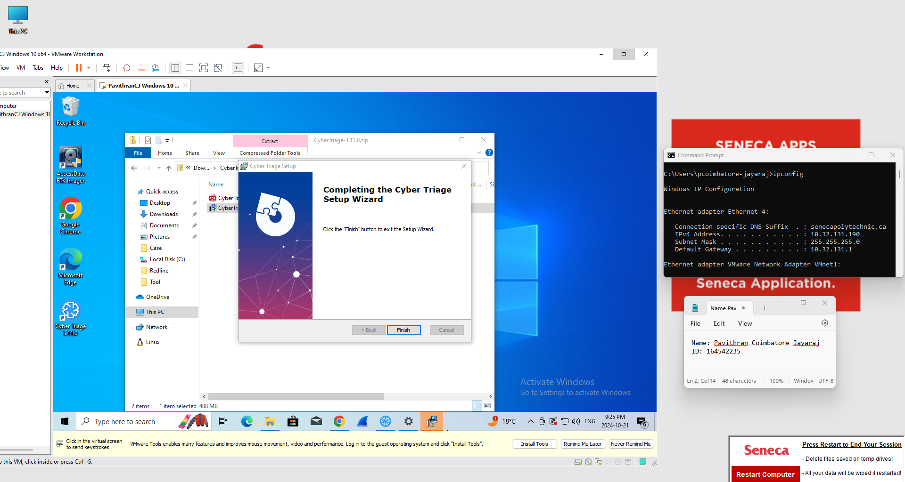

* Cyber Triage was used here to evaluate the state of a Windows 10 machine, detect potential security threats, and flag bad or suspicious items based on file behaviors and system activity logs. I loaded the memory image and started analysing the image.

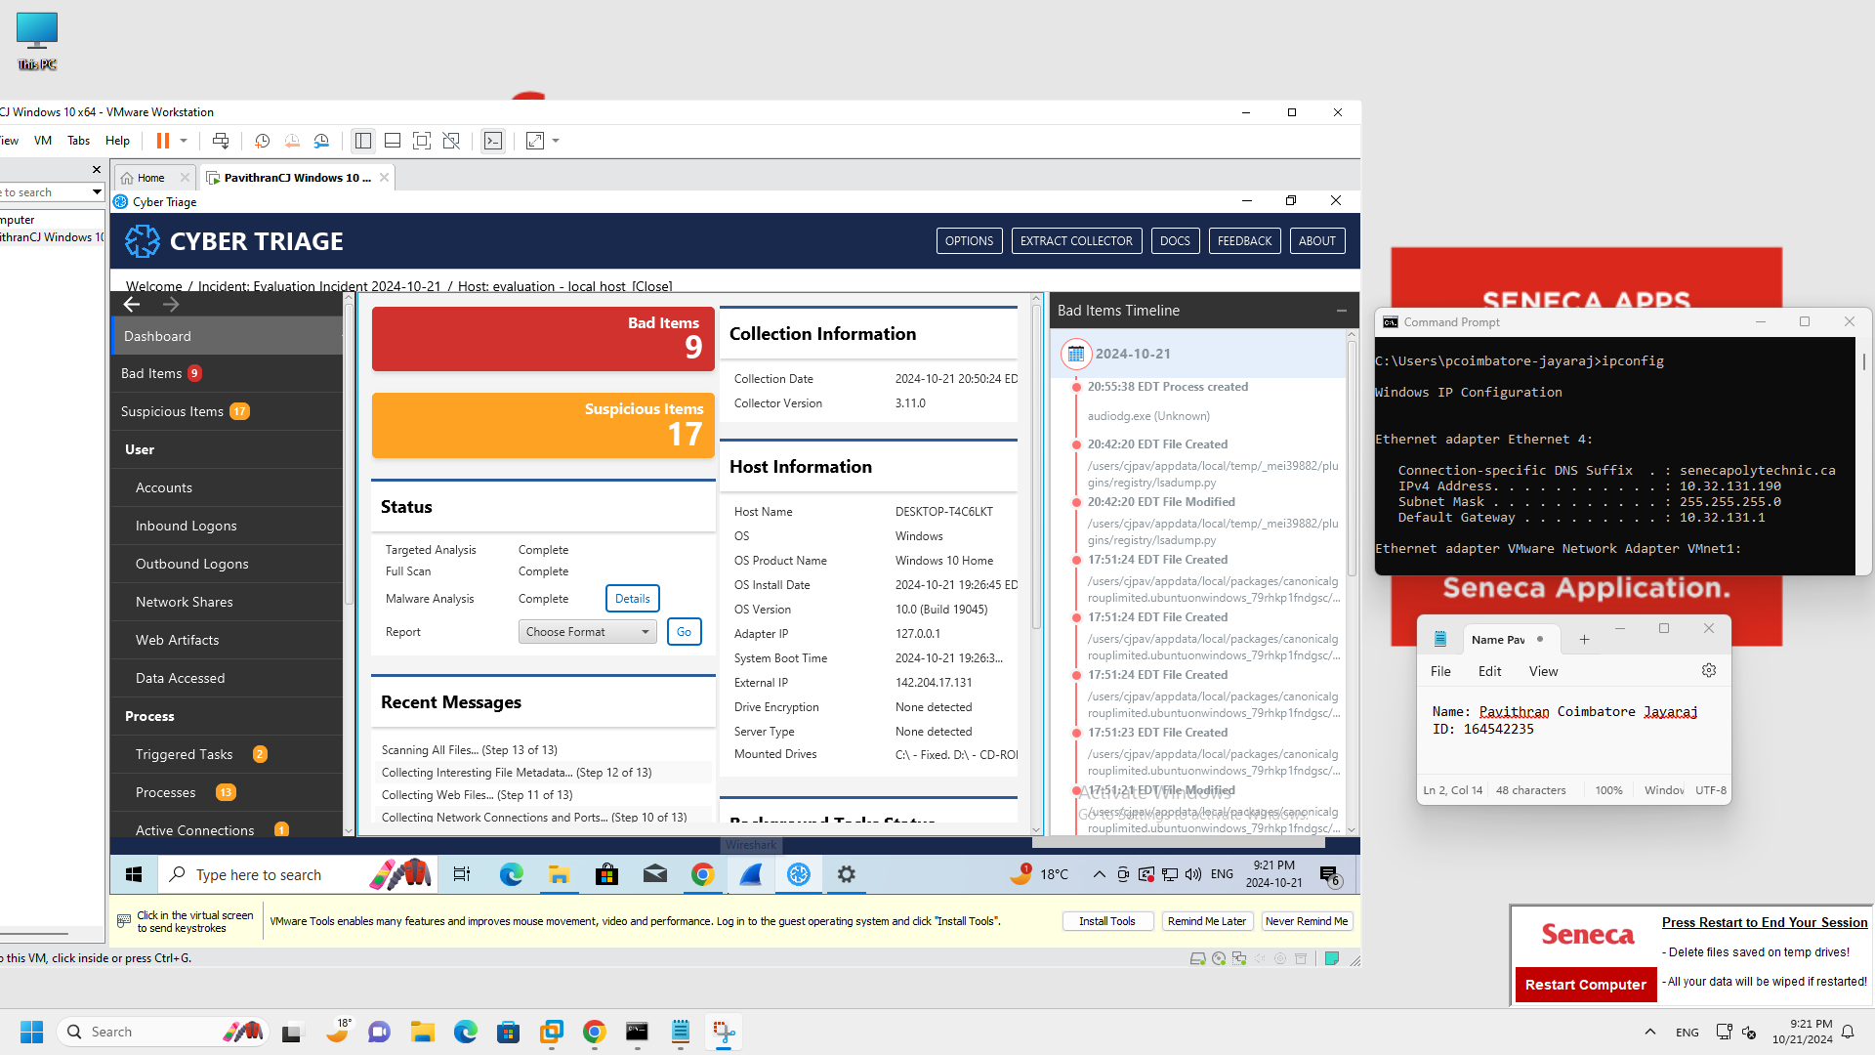

* The result shows all the bad and subspinous items we can investigate. Each of them by going into the directory and taking a look at it.

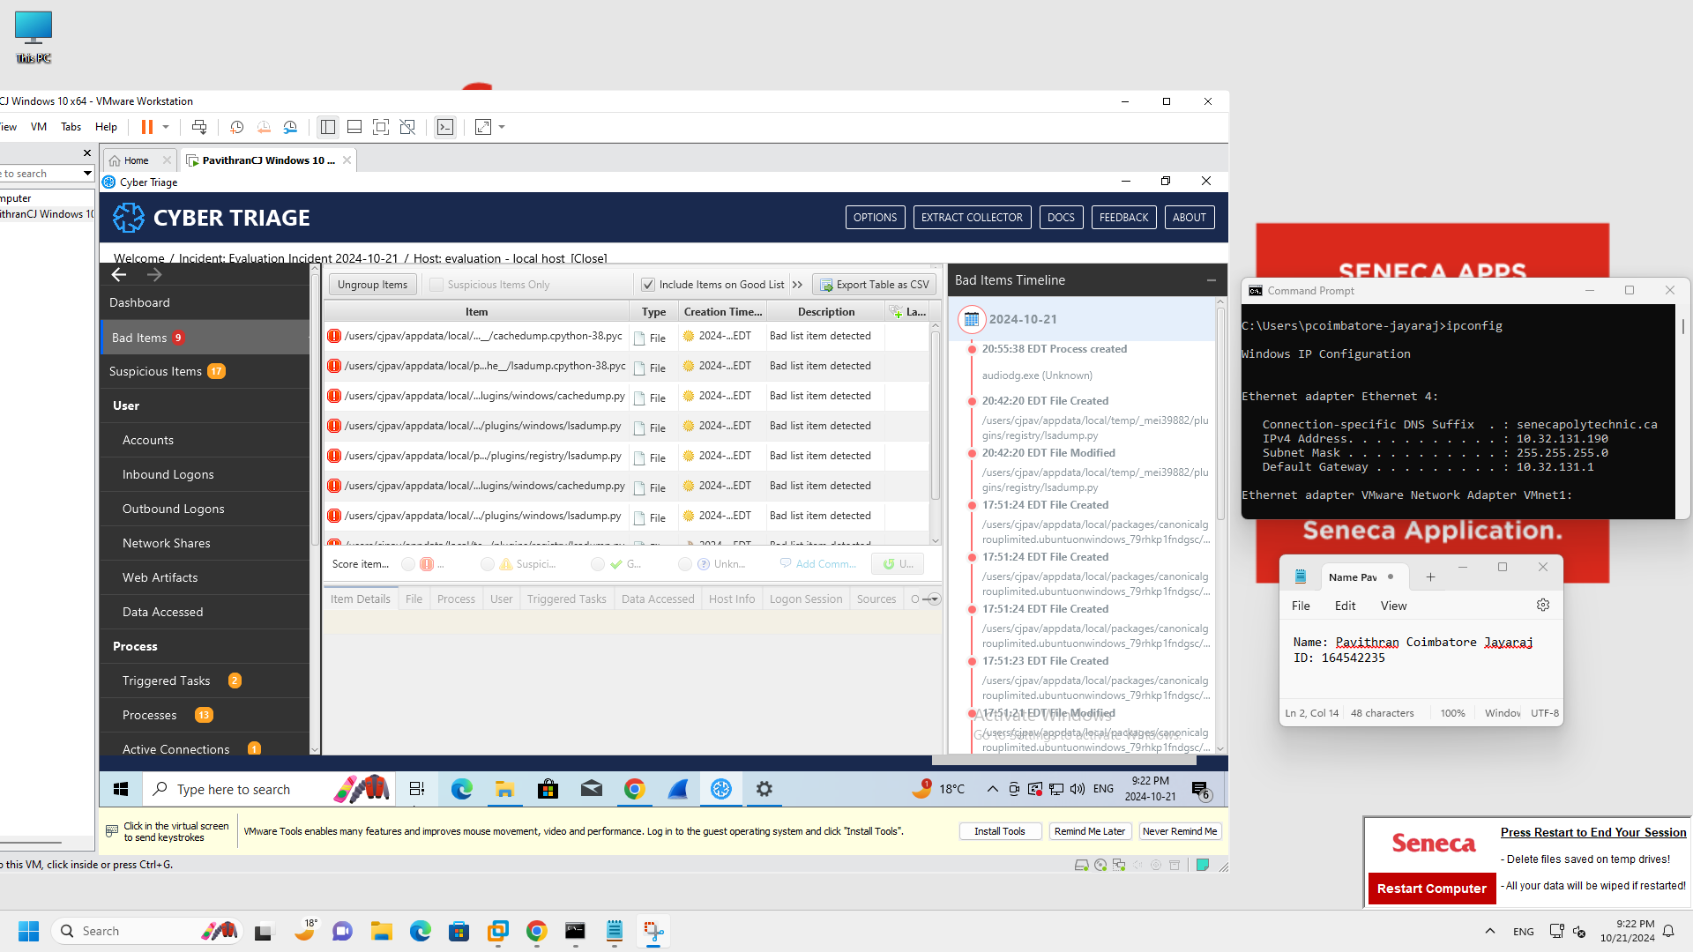

**Part 3: Personal Learning experience.**

Establishing the forensic workstation on the MacBook was quite a challenging journey, but it definitely came with its own set of obstacles. At first, my intention was to utilize VMware Fusion in order to establish the virtual environment for analyzing memory and malware. Regrettably, my VMware Fusions Windows 11 became corrupted, causing a significant setback for me. I needed to change to UTM, but I encountered a problem when I was unable to disable the secure boot feature, which was crucial for capturing the memory image correctly. Finding a Windows 10 ARM ISO file proved to be much harder than anticipated, which made it impossible to use VirtualBox. At that moment, it dawned on me that I had no other option but to go to our college and utilize the computers there to continue with my tasks.  
  
After arriving at the college, I started arranging the forensic environment which led to a smoother workflow. I focused on setting up important tools such as Volatility, Redline, and Cyber Triage. Both Volatility and Redline were easier to understand compared to other tools, each with its own individual learning curve. Nonetheless, the analysis of Cyber Triage required more time than expected. However, the process provided me with a valuable opportunity to gain practical experience in the time-consuming nature of forensic investigations, especially when faced with extensive data sets or complex situations.

In spite of the challenges, this project provided valuable lessons on establishing a forensic workstation from the beginning and utilizing various tools to examine memory dumps for potential malware or malicious behavior. I gained a complete grasp of memory analysis by utilizing the unique capabilities of each tool: Volatility, Redline, and Cyber Triage. Reflecting on the past, I acknowledge how these obstacles have enhanced my comprehension of the technical and logistical elements of forensic investigation. Overall, despite the challenging nature of the process, it was highly gratifying.